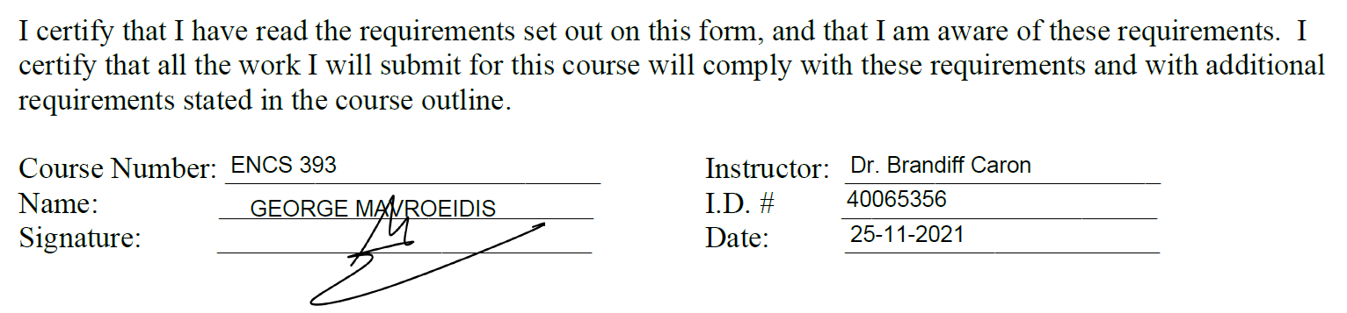

Is the reinforcement of gender equality in tech necessary?

The gender gap within technological development and more specifically computing has been an increasingly alarming case in recent history. According to Ottawa-based Information and Communications Technology Council (ICTC), with support from Microsoft, only 25% of the tech industry is women and get paid $7,000 less annually [1]. Clearly, there is an undeniable schism that companies and governments are putting effort to balance off, but their poor resolutions only made it more divided. The insincere effort to encourage gender equality in tech has led to a greater concern regarding the gender gap. Focusing too much on the gender inequality in tech only reinforce their distinction between men. In addition, misunderstanding how they want to be represented in tech is a pitfall that firms overlook when hiring them.

Spotlighting the gender gap within tech has imposed firms to vigorously promote inclusion and equality without actually doing so correctly. “By constantly spotlighting that ‘women in tech are capable too’, it underlines the norm to think of women as less capable. Otherwise, there would be no need to highlight this fact at all” [2]. Subconsciously, firms hire women based on their gender to fill in that gap. As much inclusion is necessary, women want to be hired for their skills, achievements and their work ethic, just like males would and not for their difference in natural characteristics. For example, tech award shows may have categories specifically for women, which clearly continues to represent women as inferior and less capable of great achievements. Gender neutral awards celebrate accomplishments equally and humanely. This humanizes women, “showing that they too have worries, fears, and weaknesses. If they can make it in the industry, others can too.” [2].

It is often overlooked how capable women are in other prestigious fields using technology such as nursing, biology, chemistry and more. Therefore, them being portrayed as unqualified or inadequate to take on tech roles is highly unreasonable. They are misunderstood and are not represented equally to the same standard as men, but rather as a secondary option for the purpose of inclusion and gives the wrong message to critics of the gender gap. Normalizing women in tech does not mean focusing on their gender to be a part of it, but neither ignoring it. This means “being conscientious about putting women on the same stages and platforms as equally accomplished men — without making a public deal about it” [2]. For example, most universities have tech societies, such as Women in Engineering or Women in Computer Science. Many critics believe it is counterproductive to promote gender reinforcement in a gender-neutral space, the university. On the contrary, these societies are created with the purpose of making women visible by demonstrating that gender should not be the determining factor when it comes to contributing in tech or any other similarly imbalanced fields. Many of their networking events are not women-exclusive, which further confirms the unimportance of gender-focused guidelines and concerns in the workforce. Education is key and problems are only solved when both sides have a voice and are heard equally.

In conclusion, there is a fine line between normalizing women in tech and not making their gender the baseline for their career path and salary decisions. Gender equality is encouraged the wrong way and has created greater concerns in the future prospects of inclusion. Society focuses entirely on the fact that there are women rather than determining their success based on the same reasons we evaluate men’s careers. In addition, women’s desired representation in tech is often misunderstood and it is a common point firms and governments overlook when they are trying to regulate gender equality. The core intention of gender equality is to show that being a woman is not particularly remarkable and that their gender does not define their capabilities compared to men’s.

References:

1. R. Pringle, “*Gender gap shows high-tech sector still stuck in the past — and it could prove costly*”, 12-Feb-2018. [Online]. Available: cbc,ca, https://www.cbc.ca/news/science/diversity-tech-jobs-pringle-1.4528149. [Accessed: 09-Nov-2021].
2. E. Leong, “*We shouldn’t make a big deal about women in tech — a female entrepreneur’s perspective*”, 04-Dec-2020. [Online]. Available: todayonline.com, https://www.todayonline.com/commentary/we-shouldnt-make-big-deal-about-women-tech-female-entrepreneurs-perspective?cid=tdy%20tg_tg. [Accessed: 09-Nov-2021]